**Project : Desktop Publishing (23CAP-204)**

Student Name: PRINCESS NCUBE

UID: 23BCA10586

Branch: 23BCA

Section: 8A

Semester: 3

Date of Submission: 04 /11/2024

**PROJECT TITLE** : Design a poster for an event.

**AIM:** **Music Concert Poster Design**

**APPLICATIONS USED:**

**1. Adobe photoshop 2017 –**For poster design.

**2. Microsoft edge –**for image extraction.

**3. Camera –**for taking event pictures to be used on the poster.

**4.Microsoft word 2010 –**for project report preparation.

**Step 1: Gather Materials**

- Event Details: Date, time, location, lineup.

- Images: High-resolution images of artists/bands, background images, and logos.

- Fonts: Select fonts that match the concert theme.

**Step 2: Set Up Your Photoshop Document**

1. Open Photoshop.

2. Create a New Document:

- Size: A4 (9.5 x 13 inches)/1080 width and 1080 height.

- Resolution: 300 DPI for print quality.

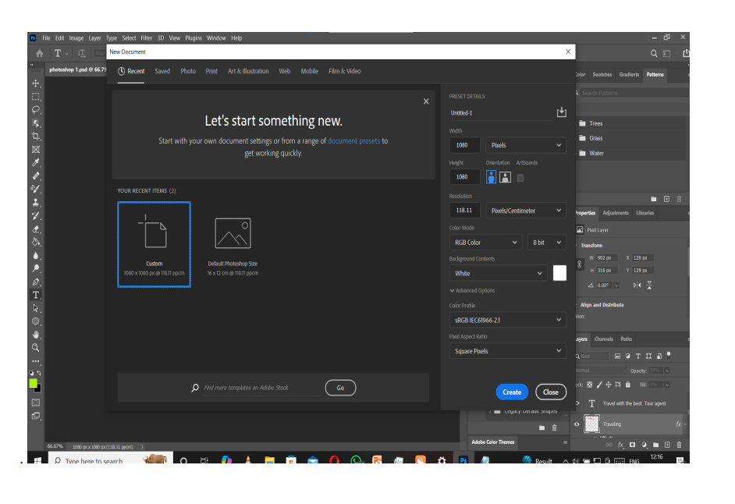  
your psd file has been created.

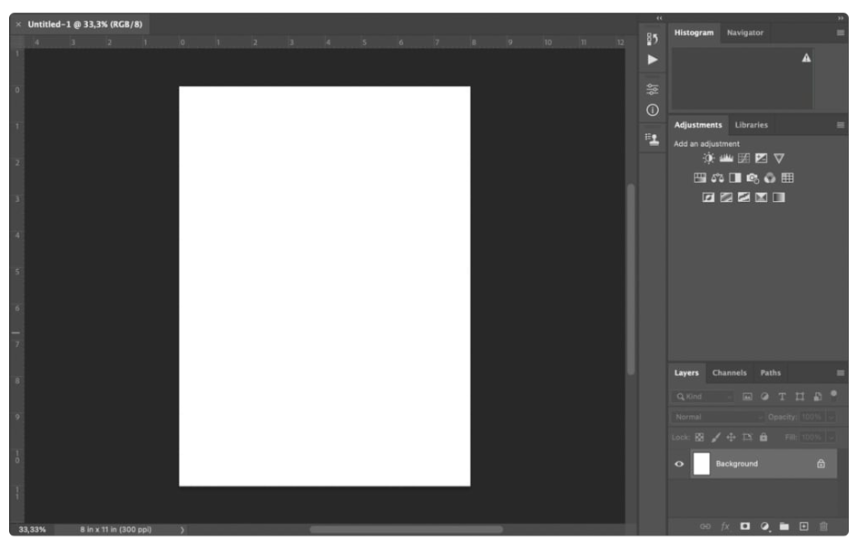

**Step 3: Choose a Background**

- Use a Solid Color or Gradient:

- Select the Gradient Tool for a dynamic background.

- Alternatively, import a high-quality image as your background.

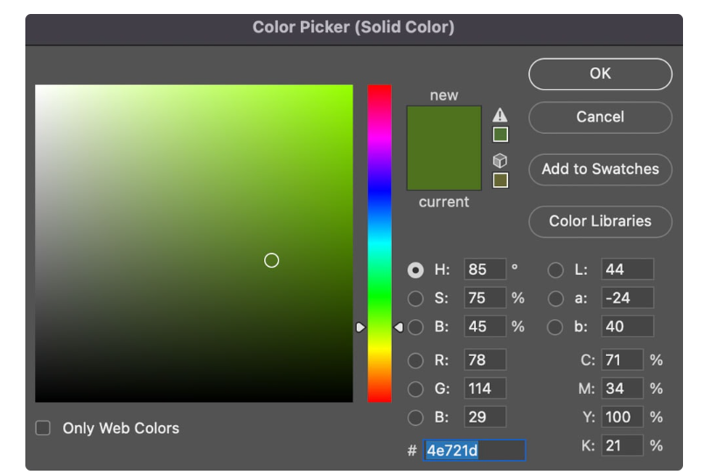

**Step 4: Add Images**

1. Import Artist Images:

- Use `File > Place Embedded` to add images of performers.

- Use the Pen Tool or Quick Selection Tool to cut out the background if necessary.

2. Position and Resize:

- Use the Transform Tool (Ctrl + T) to resize and position images.

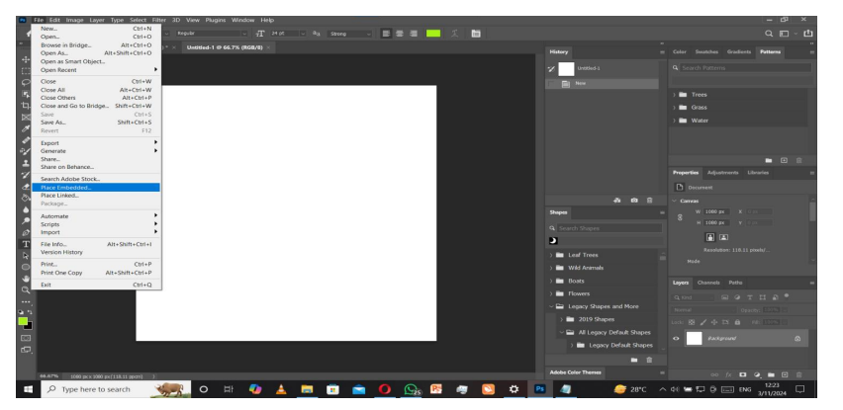

**Step 5: Insert Text**

- Event Title: Use a bold, eye-catching font.

- Details: Add date, time, and location using a readable font.

- Lineup: List performers in a clear manner.

- Example:

```

LIVE IN CONCERT

[Jah Prayzah]

[25 November 2024]

[Meikles Hotel]

**Step 6: Style Your Text**

- Text Effects: Use Layer Styles (e.g., drop shadows, strokes) to make the text stand out.

- Alignment: Center text or align it creatively with images.

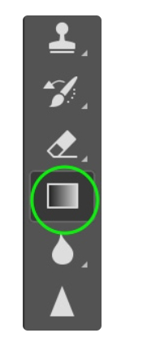gradient tool

**Step 7: Add Additional Elements**

- Logos: Include sponsor or venue logos.

- Decorative Graphics: Add music notes, instruments, or abstract designs for flair.

- Borders/Frames: Consider adding a border to enhance the overall look.

**Step 8: Final Adjustments**

- Color Correction: Adjust the overall color balance using **Adjustment Layers**.

- Review Layout: Ensure all elements are balanced and visually appealing.

**Your poster will look like this :**

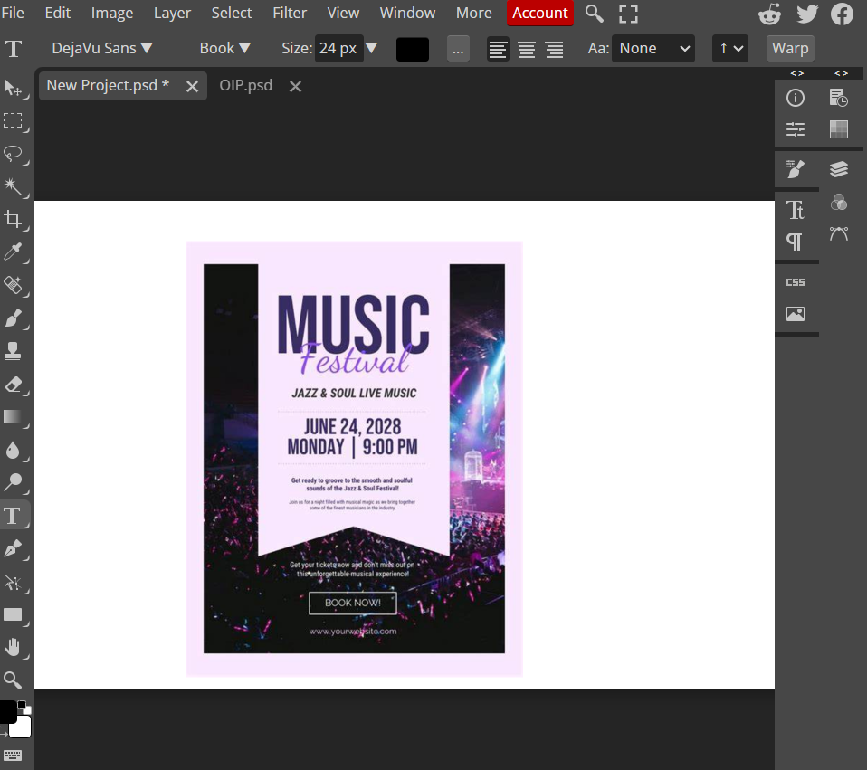

**Step 9: Save Your Work**

- Save as PSD: Keep a Photoshop file for future edits.

- Export for Print: Use `File > Export > Export As` to save as a high-resolution PDF or JPG.

**Step 10: Print and Distribute**

- Print: Use a professional printing service for best results.

-Digital Sharing: Create a web-optimized version for social media.

**DDITIONAL DESIGN**

1. Keep It Simple: Don’t overcrowd your poster.

2. Use High-Quality Images: Ensure all visuals are high resolution.

3. Contrast: Make sure text contrasts well with the background for readability.

**OUTPUT**

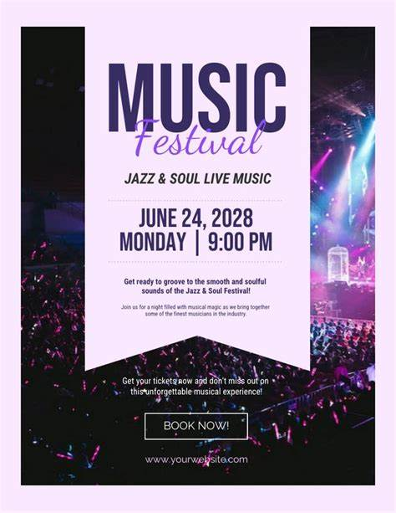

**Learning outcomes /conclusion:**

1. Effective design ,planning and composition. Deciding on the layout, background, and text placement ensured that the final product communicates the message clearly and attractively.

2. Color theory to create contrast between the text and background ensures readability and visual appeal.

3. Choosing the right fonts and applying text effects (like drop shadows or outlines) can significantly impact the design's tone and clarity.